**Kamala Education Society’s**

**Pratibha College of Commerce & Computer Studies, Chinchwad, Pune-19**



**A**

**Project Report On**

**“BillBox-**

**a simple invoice creator’’**

**Developed by,**

**8610: Akash Singh T.Y.BSC (C.S)**

Under

**Savitribai Phule Pune University (2023-2024)**

**Kamala Education Society’s**

**Pratibha College of Commerce & Computer Studies, Chinchwad, Pune-19**



**Certificate**

This is to certify that Akash .H. Singhhave satisfactorily completed the **“BillBox -A Simple Invoice Creator for professionals ”** for **T. Y. BSC (CS)** under the **Savitribai Phule Pune University** in the academic

year **2022-2023.**

**Mrs. Charushila Patil Dr.HarshitaVachhani**

**Project Guide Program Coordinator**

**Internal examiner External examiner**

**Date:**

**ACKNOWLEDGMENT**

Any efforts to produce successful creation require the help. Guidance and support of many people and their experience. We would like to express our sincere and heartfelt gratitude to all of them who have helped us to complete project.

We would like to take this opportunity to thanks all the people who have directly or indirectly helped in completing this project. We would like to thank our guide **Dr. Harshita Vachhani Mam and Prof. Charushila Patil Mam** , for her valuable guidance.

We are thankful to and fortunate enough to get constant encouragement, support and guidance from all teaching staff which helped us in successfully completing our project work. Also, we would like to extend our sincere esteems to all staff in laboratory for their timely support.

**-Akash .H. Singh**

**Table of Contents**

|  |  |
| --- | --- |
| **Particulars** | **Page No.** |
| **Abstract (Short Summary of project)** |  |
| **Introduction** |  |
| * Motivation * problem statement * purpose/objective and goals * literature survey * project scope and limitations |  |
| * System analysis * Existing systems * scope and limitations of existing systems * project perspective, features * stakeholders * Requirement analysis- Functional requirements, * Performance requirements, security requirements etc. |  |
| **System Design**   * Design constraints * System Model: Using OOSE * Data Model * User interfaces |  |
| **Implementation details**   * Software/hardware specifications |  |
| **Outputs and Reports Testing**   * Test Plan, Black Box Testing or Data Validation Test Cases, * White Box Testing or Functional Validation Test cases and |  |
| **Results**  **Conclusion and Recommendations** |  |
| **Future Scope** |  |
| **Bibliography and References** |  |

**INTRODUCTION :**

* **Online Invoice Creation Tool**: billbox is developed using HTML, CSS, PHP, JavaScript, and PostgreSQL. It is designed to facilitate the process of invoice generation for users, who need to create an account or enter their details to access their profiles.
* **User-Centric Design**: Unlike systems with administrative oversight, billbox places the control directly in the hands of its users. They are empowered to generate, view, modify, and delete their invoices, ensuring a high degree of autonomy and flexibility.
* **Simplified Billing Process**: The core objective of billbox is to provide a straightforward, user-friendly, and well-organized platform for billing creation. It emphasizes minimalism and efficiency, allowing users to easily manage their invoicing tasks without unnecessary complications.
* **Purpose of billbox**: The purpose of creating billbox is to minimize manual efforts in the billing process and offer a streamlined, efficient solution for users to manage their invoicing needs autonomously. By eliminating the need for administrative intervention and simplifying the invoice management process, billbox aims to enhance operational efficiency and productivity for its users

**PROBLEM IN EXISTING SYSTEM :**

**Limited Administrative Oversight: While empowering users to manage their invoices directly is a key feature, the absence of an administrative user to oversee operations could lead to challenges in maintaining data integrity and addressing disputes or errors in invoicing.**

**Security Concerns: With users directly managing invoice generation, modification, and deletion, there could be heightened security concerns, especially regarding unauthorized access or the potential for accidental or intentional misuse of the system.**

**Feature Limitations: Based on the described simplicity and direct management by users, billbox might lack advanced features that some users require, such as detailed analytics, reporting tools, or advanced customization options for their invoices**.

**NEED FOR SYSTEM**

**Simplification of Invoicing: There's a clear need for a system that can make the invoicing process as straightforward as possible. Billbox addresses this by allowing users to easily create, view, modify, and delete invoices, significantly reducing the complexity and time involved in these tasks.**

**Autonomy in Invoice Management: Users often require immediate access to their invoicing systems without waiting for administrative actions. Billbox meets this need by putting the power directly in the hands of the users, enhancing flexibility and responsiveness.**

**Accessibility and Usability: With its design, billbox caters to users looking for an invoicing solution that is both easy to navigate and efficient. This fills a significant gap for those who may not be technologically savvy or those who prefer a minimalistic approach to invoice management.**

**Integration of Modern Technologies: By leveraging HTML, CSS, PHP, JavaScript, and PostgreSQL, billbox stands out as a modern, web-based solution that can adapt to the evolving needs of its users, ensuring a future-proof platform for invoicing.**

.

SCOPE OF PROPOSED SYSTEM:

**User management:** User registration, login, and profile management.

**Invoice management**:creating, editing, and deleting invoices.

**Inventory management**: Keeping track of all the invoices, updating invoices in real-time, and deleting at real-time**.**

**REQUIREMENT :**

**Hardware Requirement :**

**Software Requirements** :

Language/Technology: HTML, CSS, JS, PHP , Postgresql

* Browser: Internet Explorer, Chrome or any Compatible web browsers
* Server: XAMPP Server

**DESIGN SPECIFICATION**

* 1. **ER DIAGRAM**

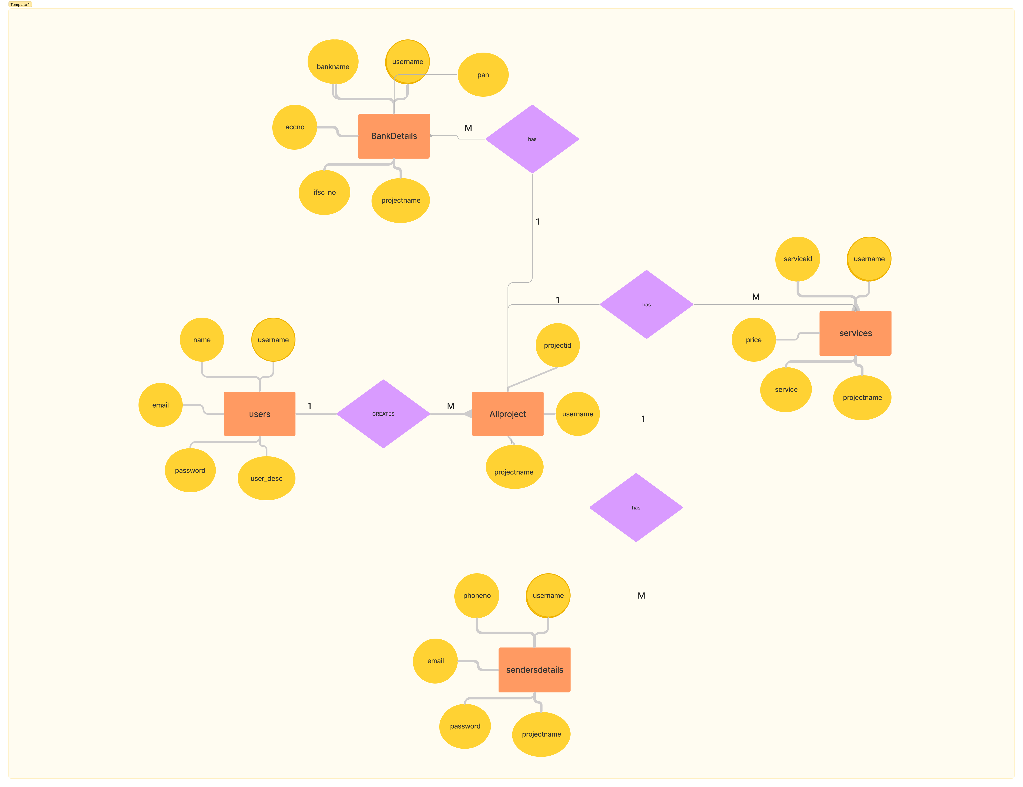

* 1. **UML DIAGRAM**

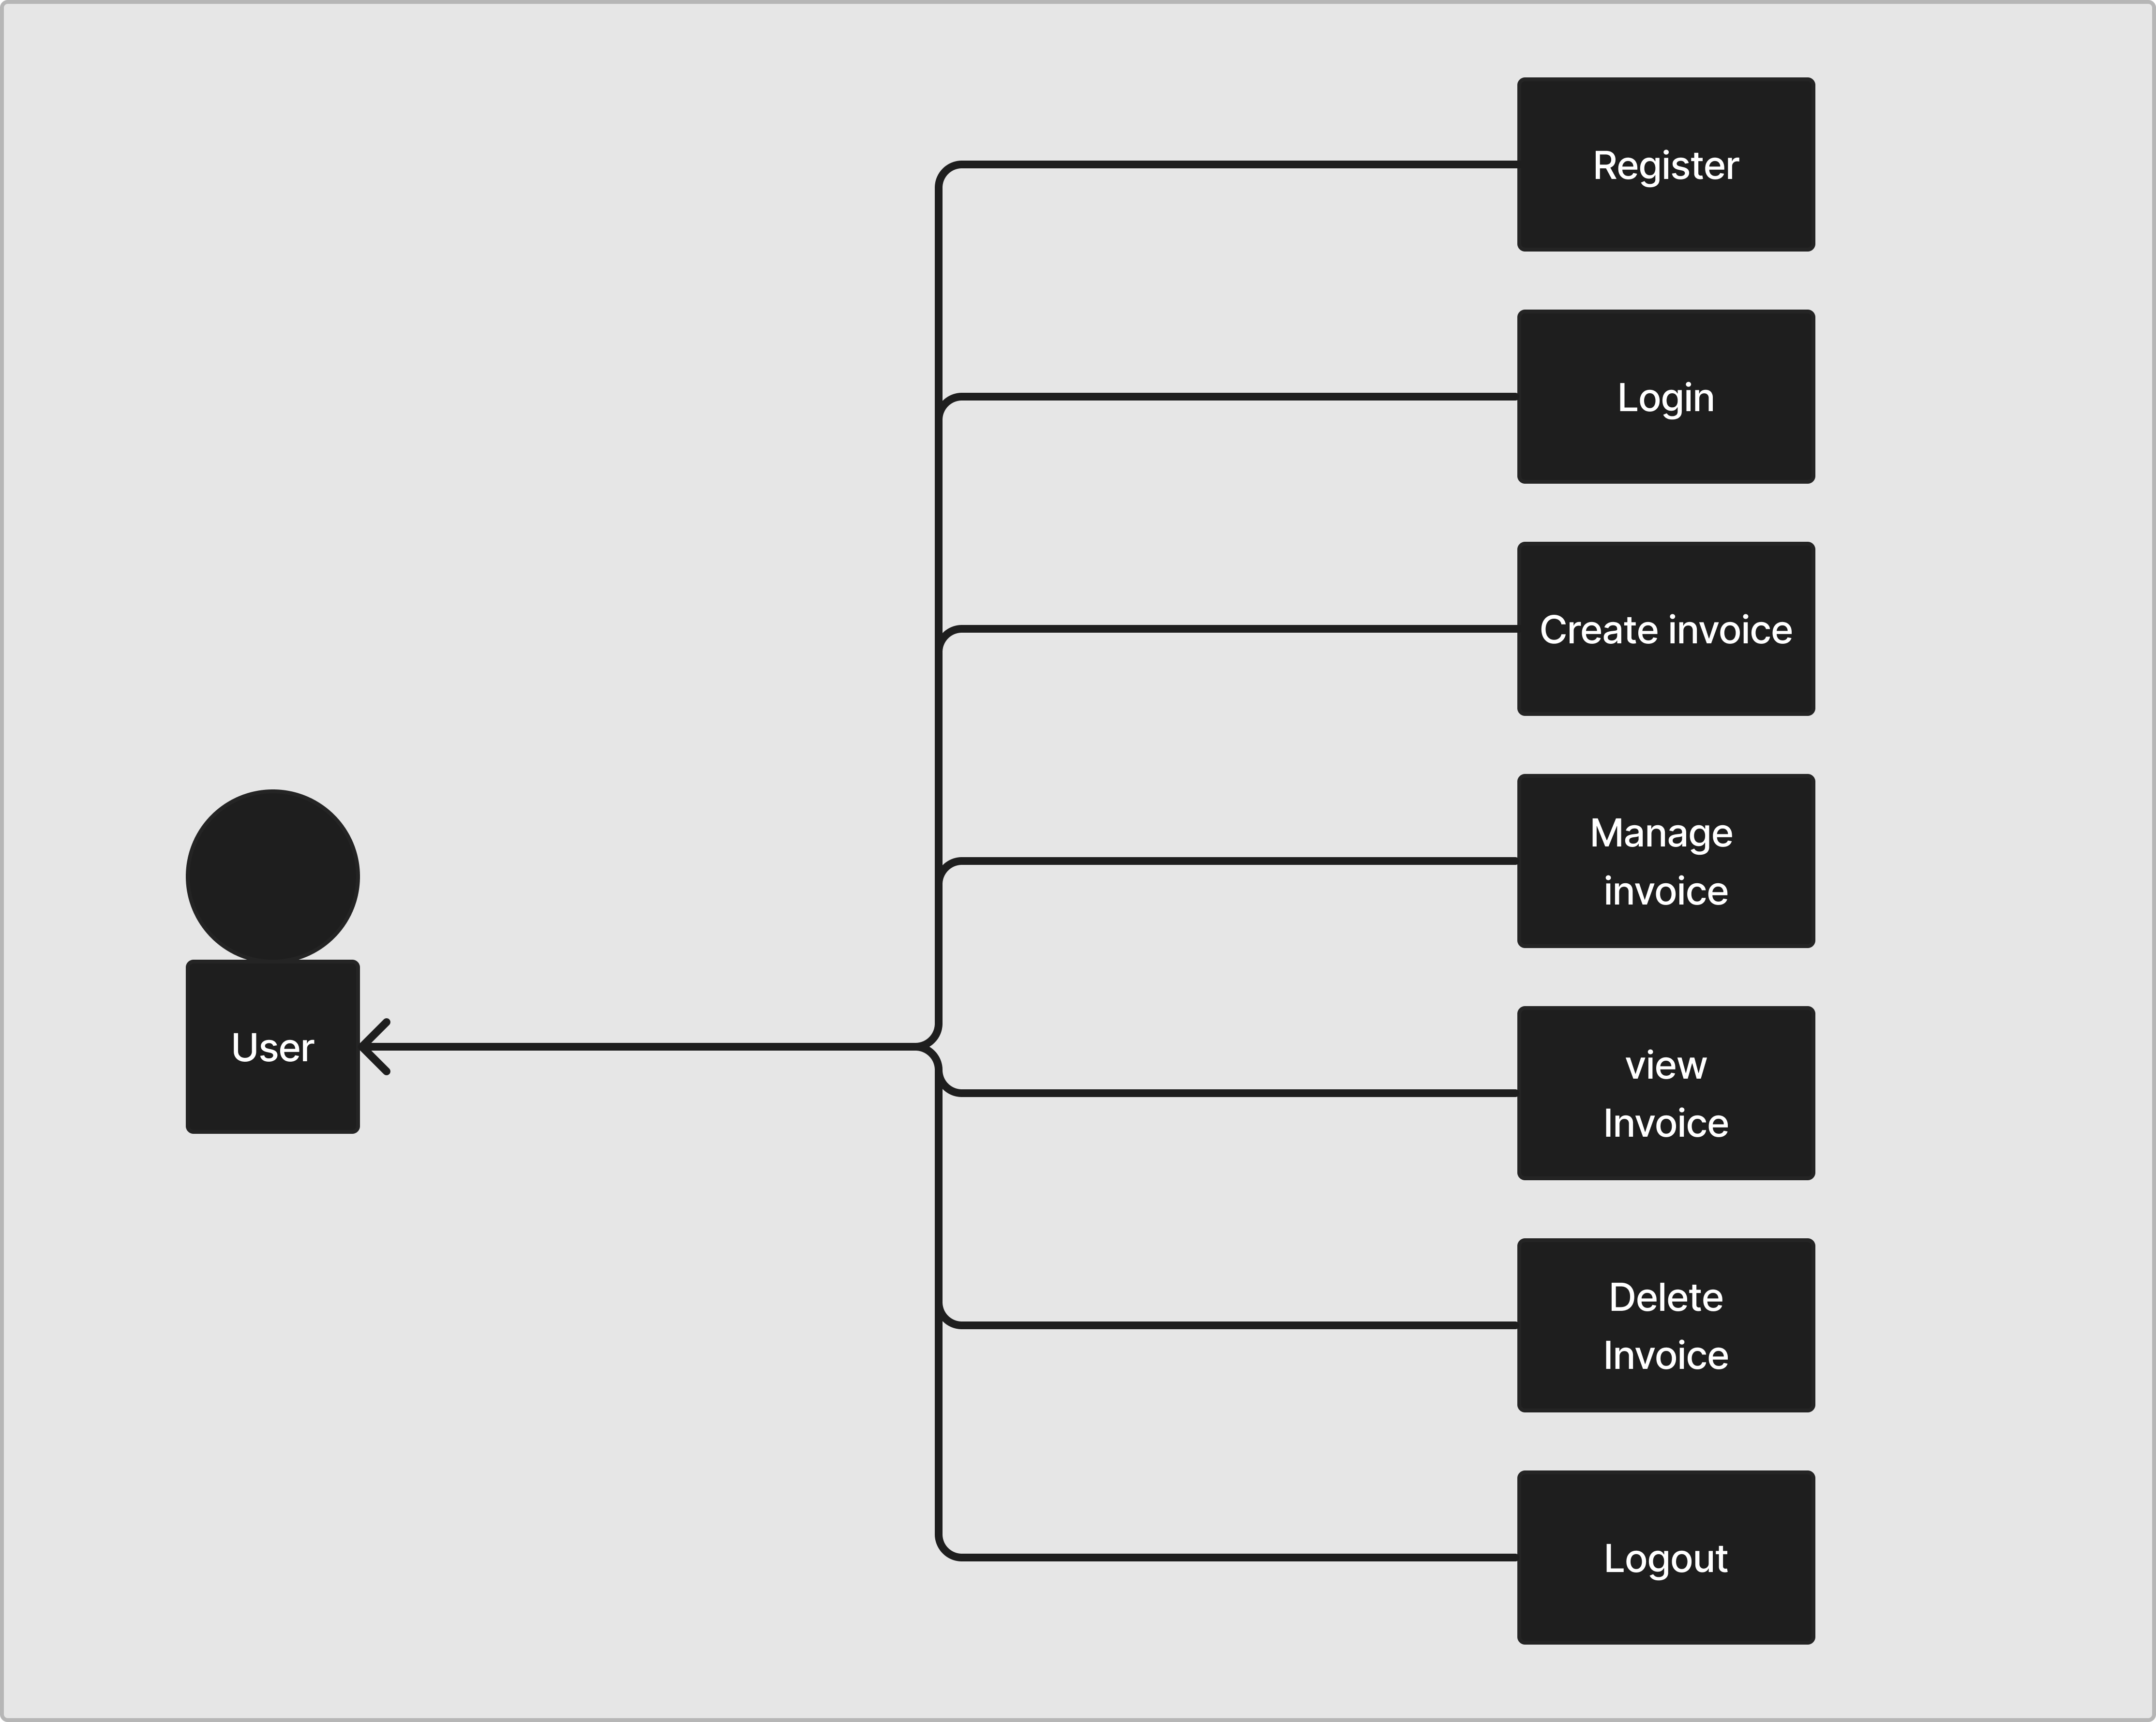

* 1. **STATE DIAGRAM**

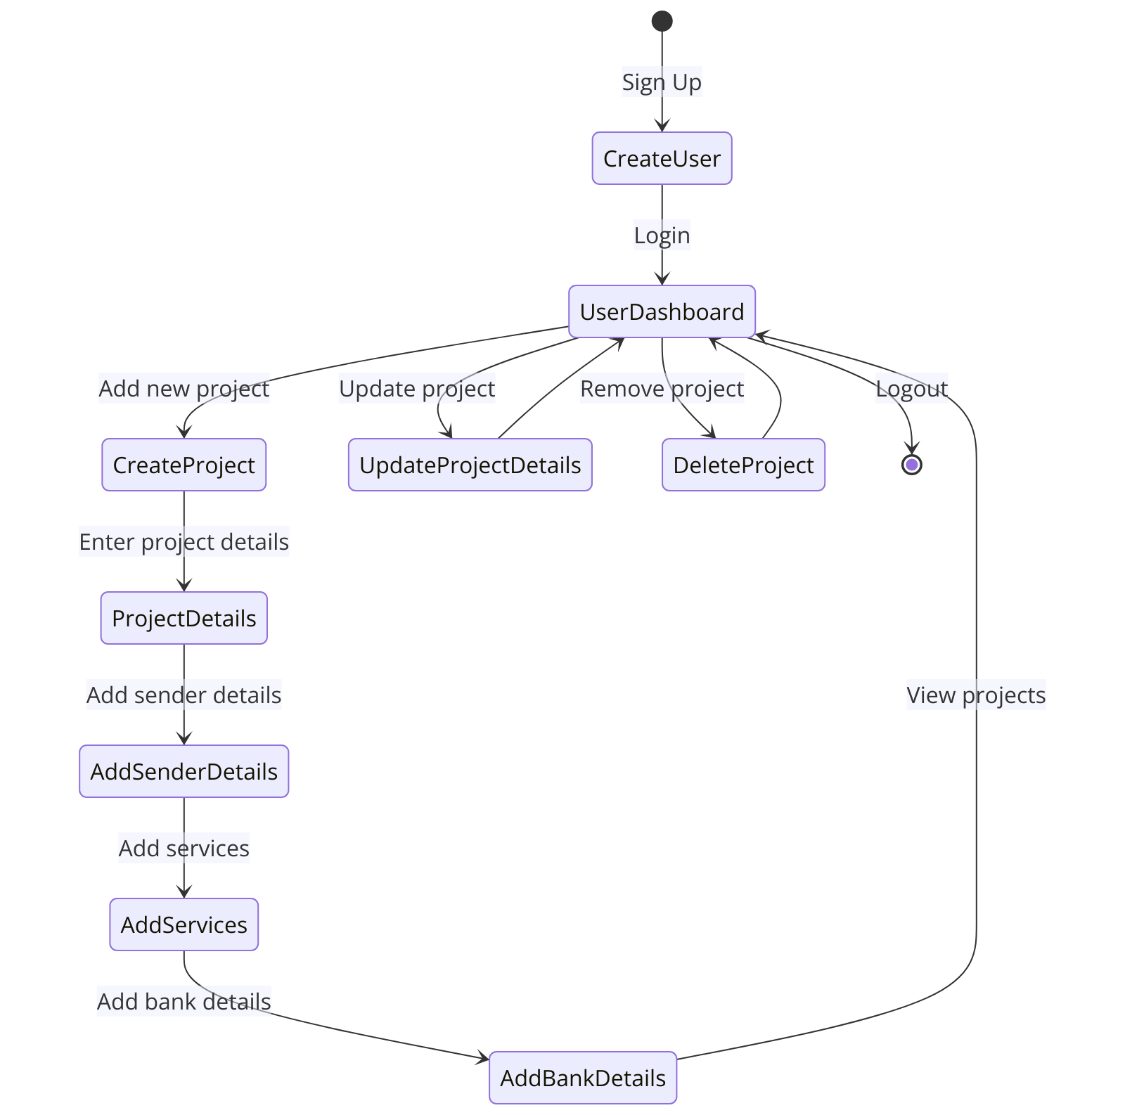

* 1. **COMPONENT DIAGRAM**

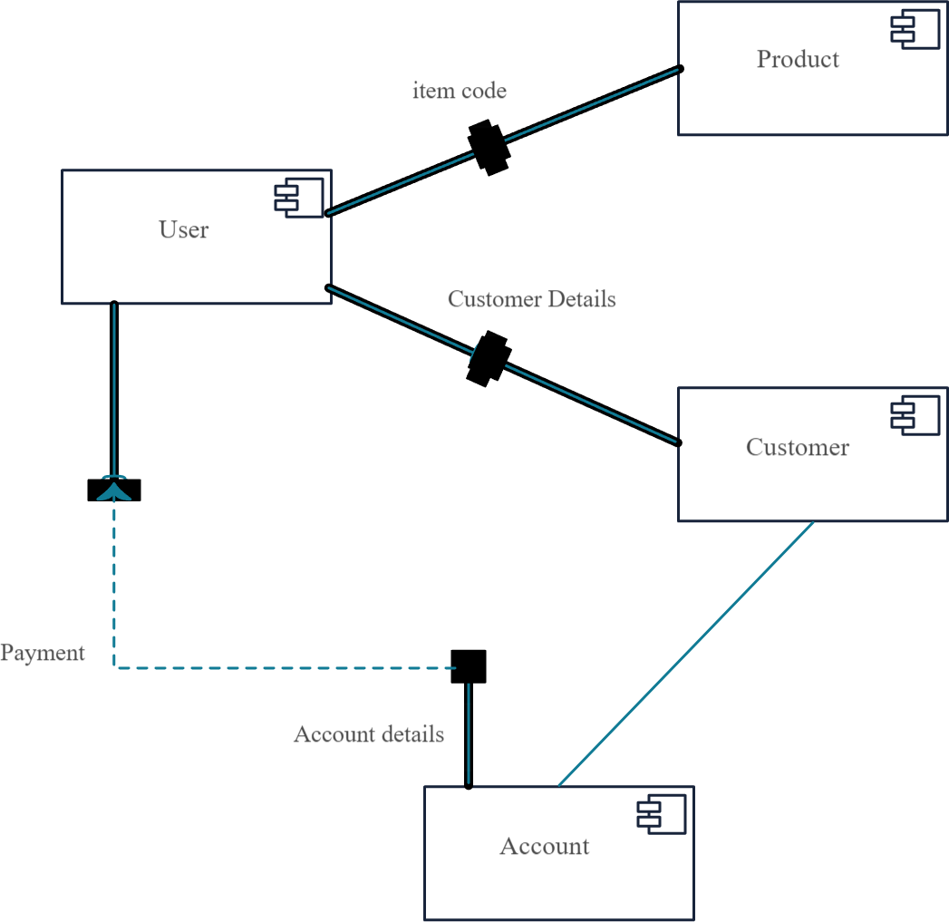

* 1. **CLASS DIAGRAM :**

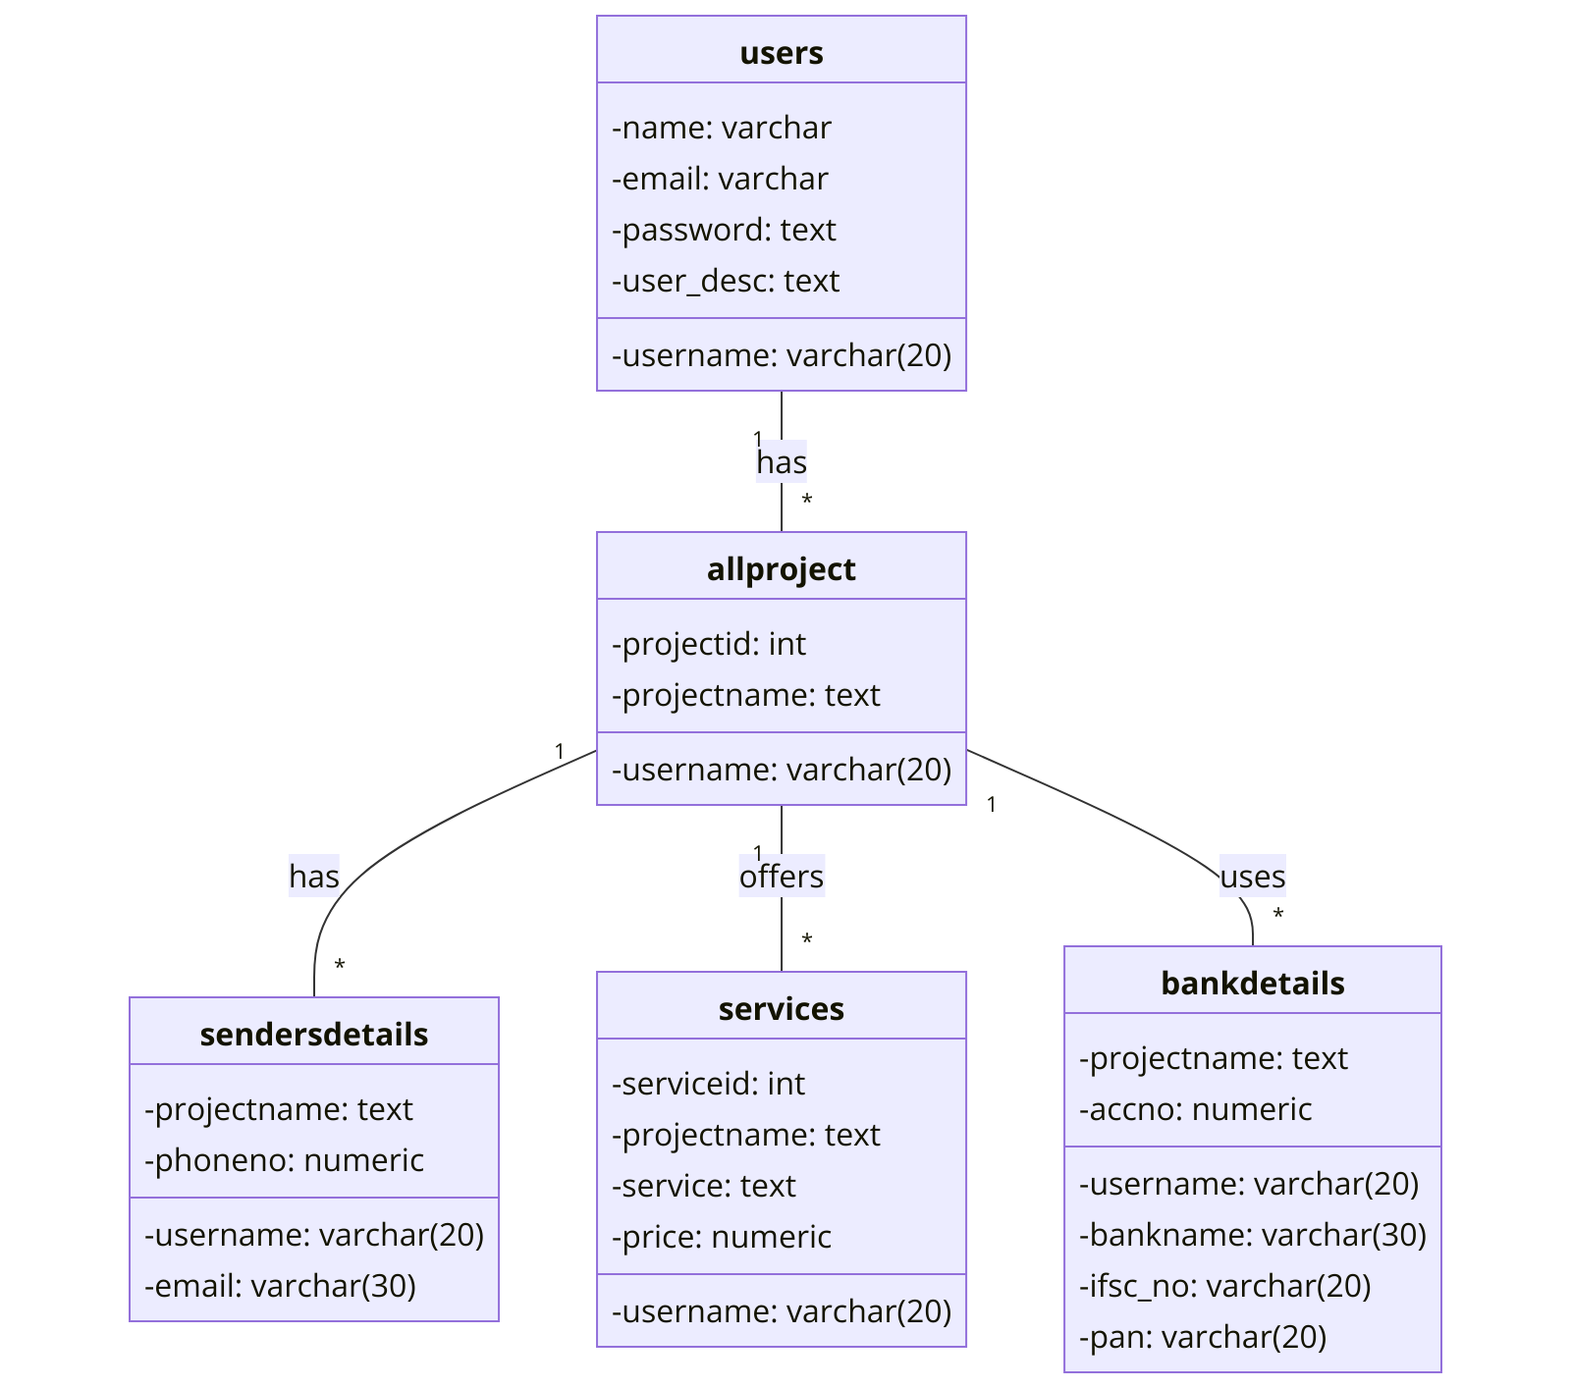

* 1. **ACTIVITY DIAGRAM:**

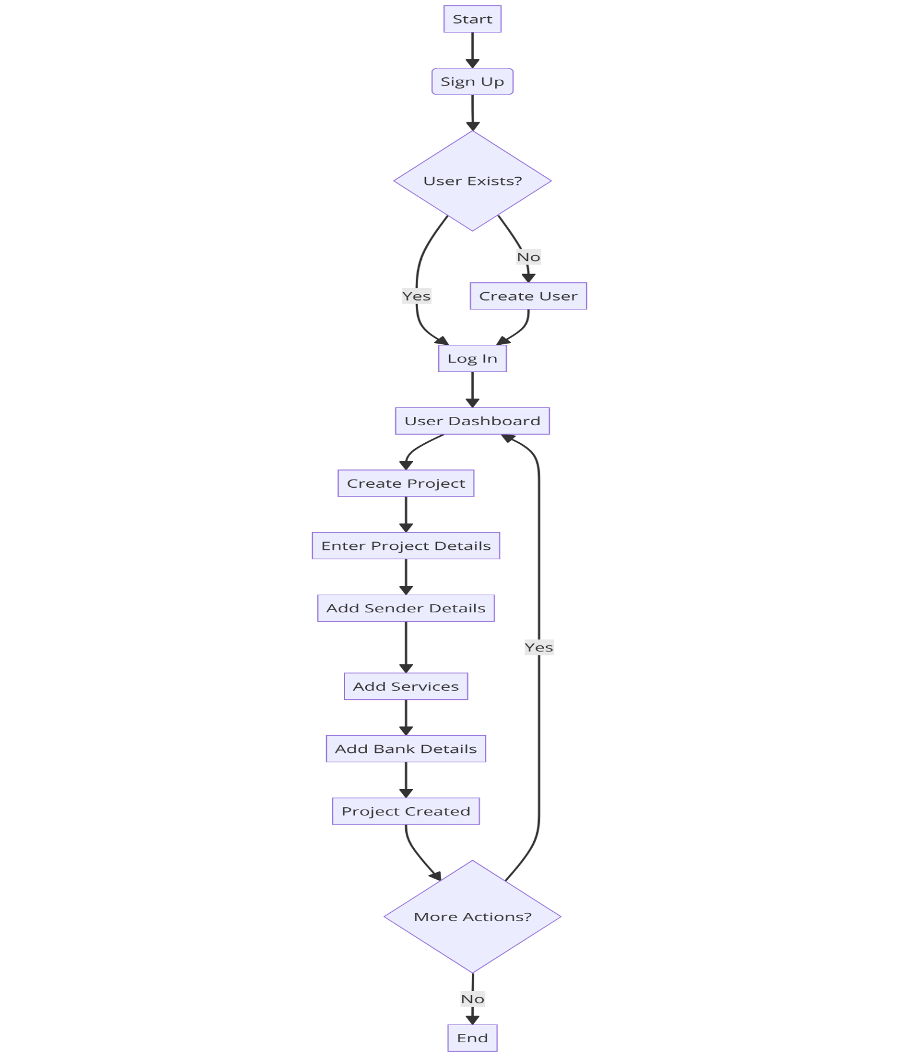

* 1. **SEQUENCE DIAGRAM**

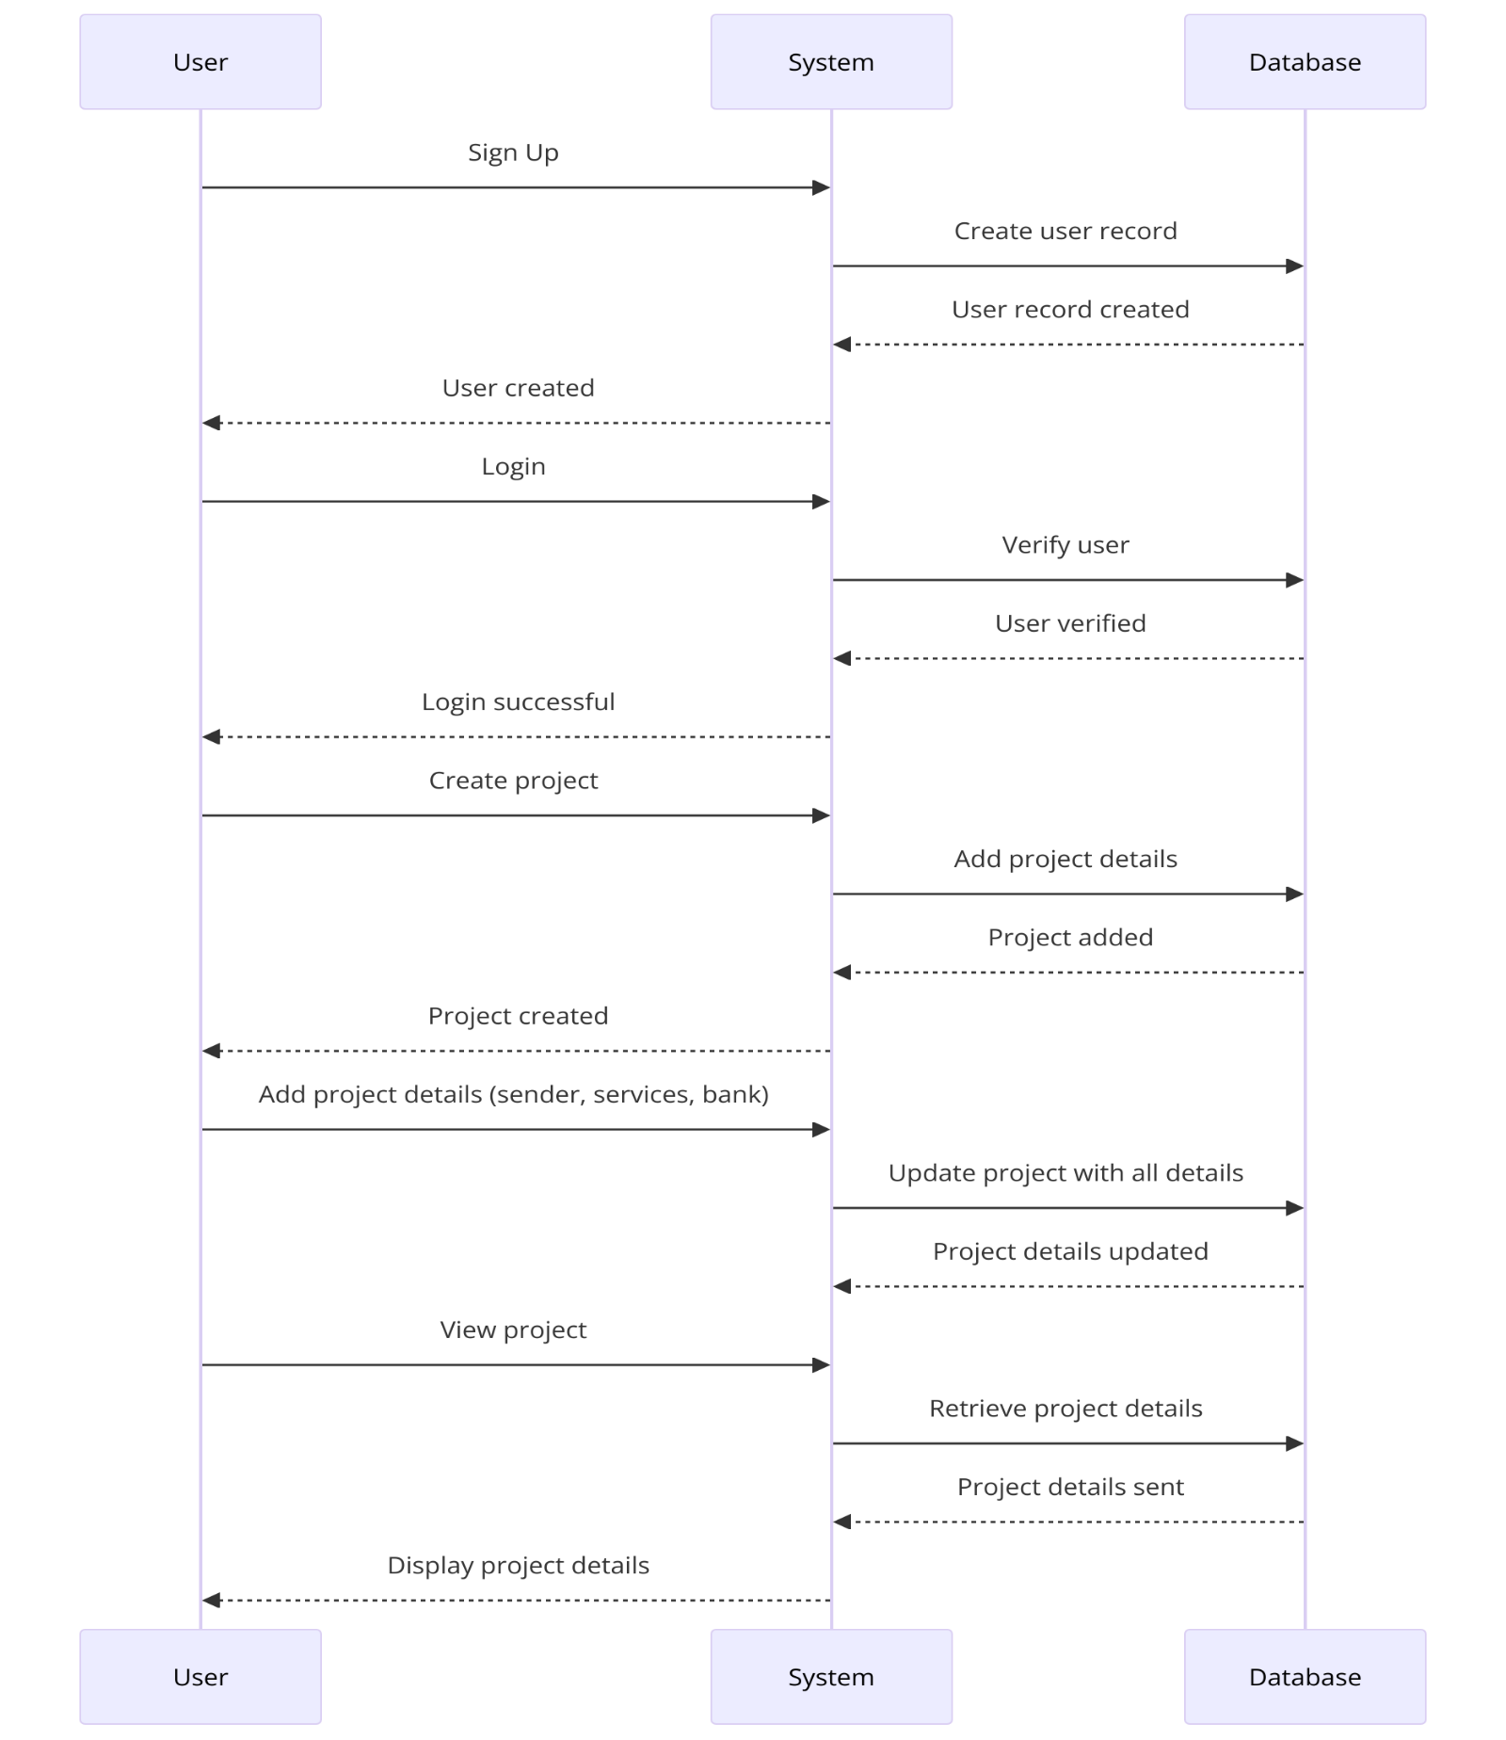

**DATA DICTIONARY:**

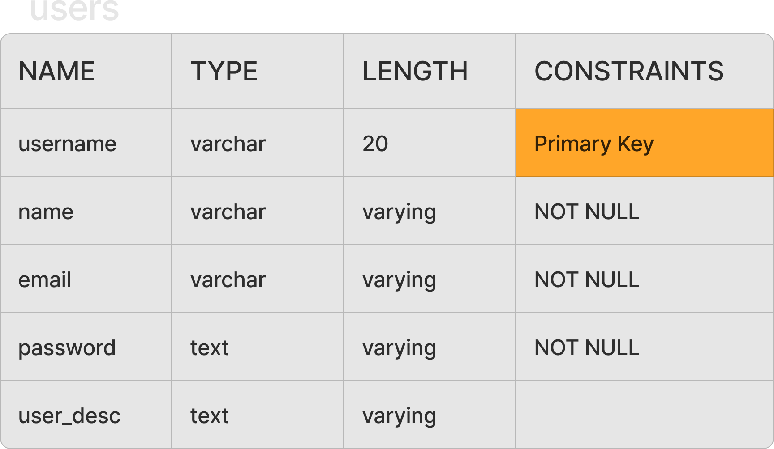

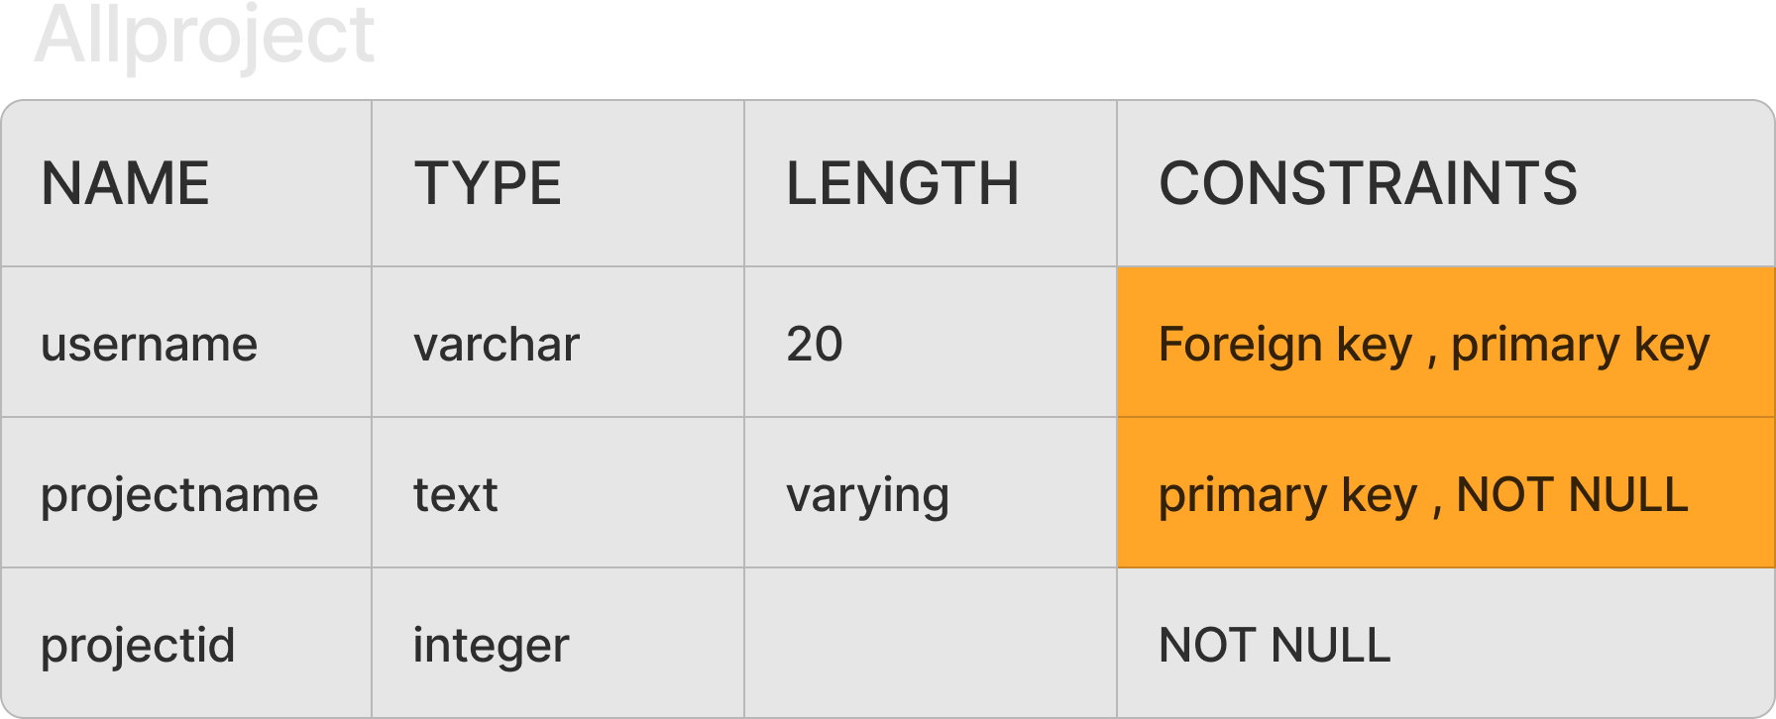

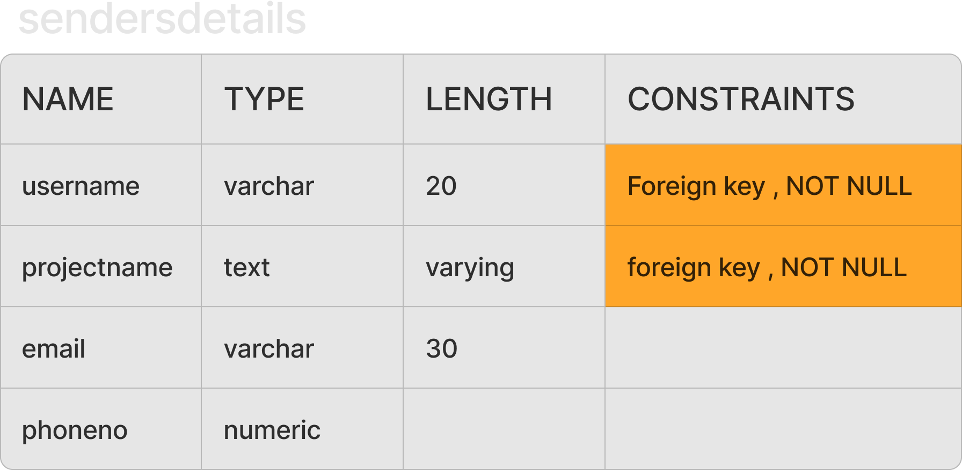

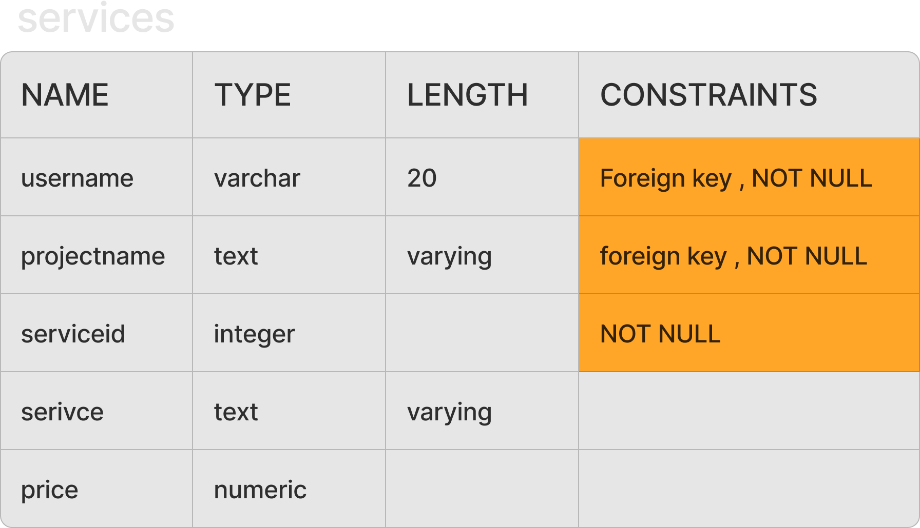

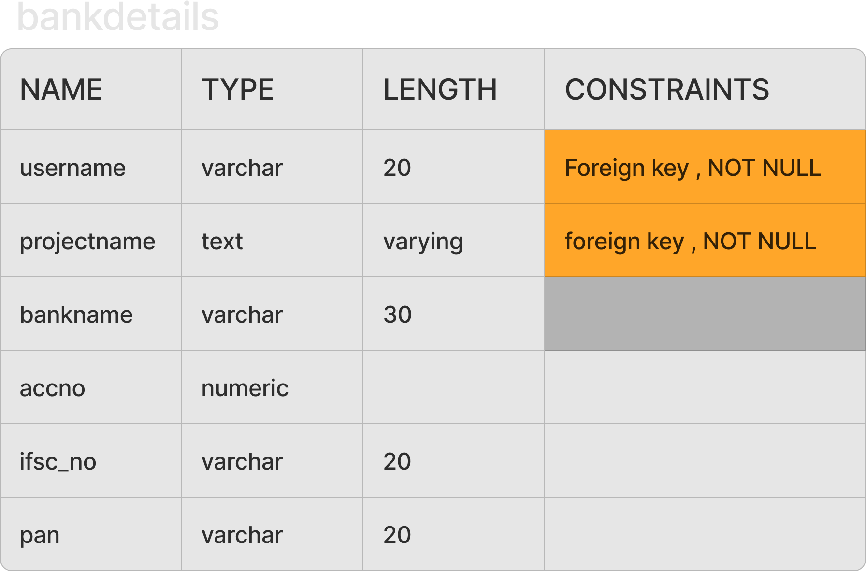

**SAMPLE INPUT & OUTPUT SCREEN :**

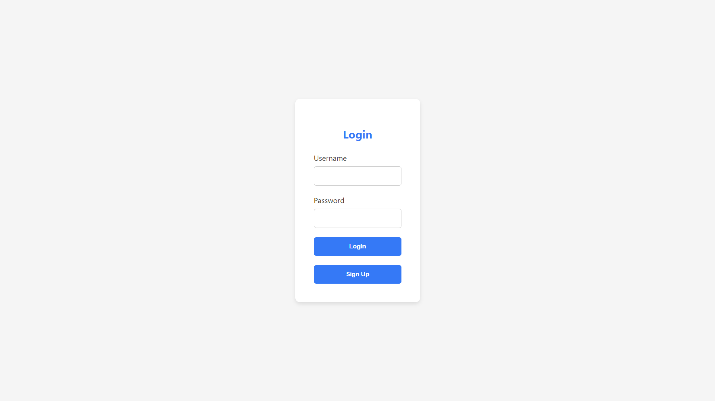

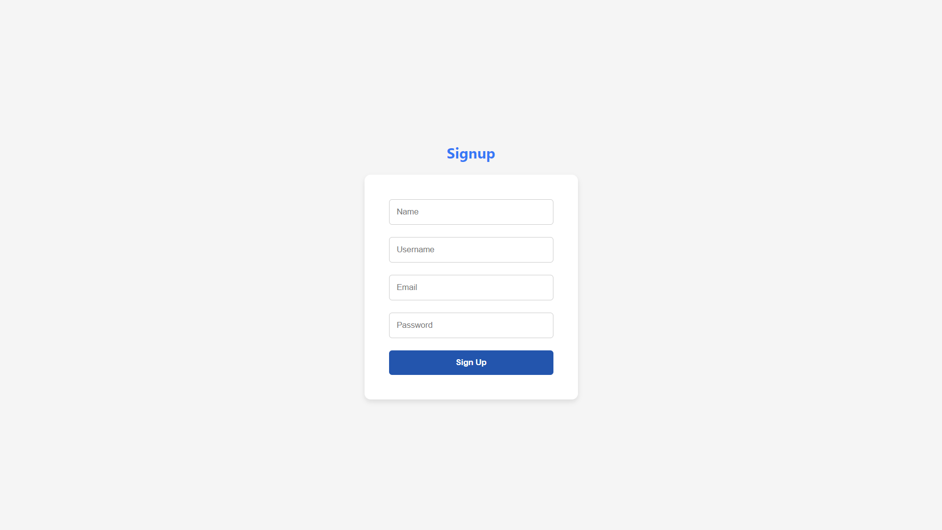

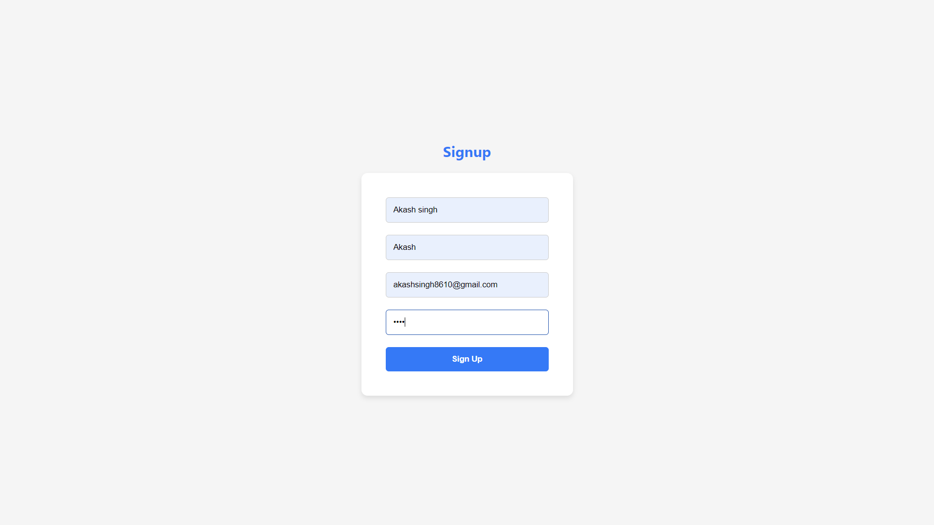

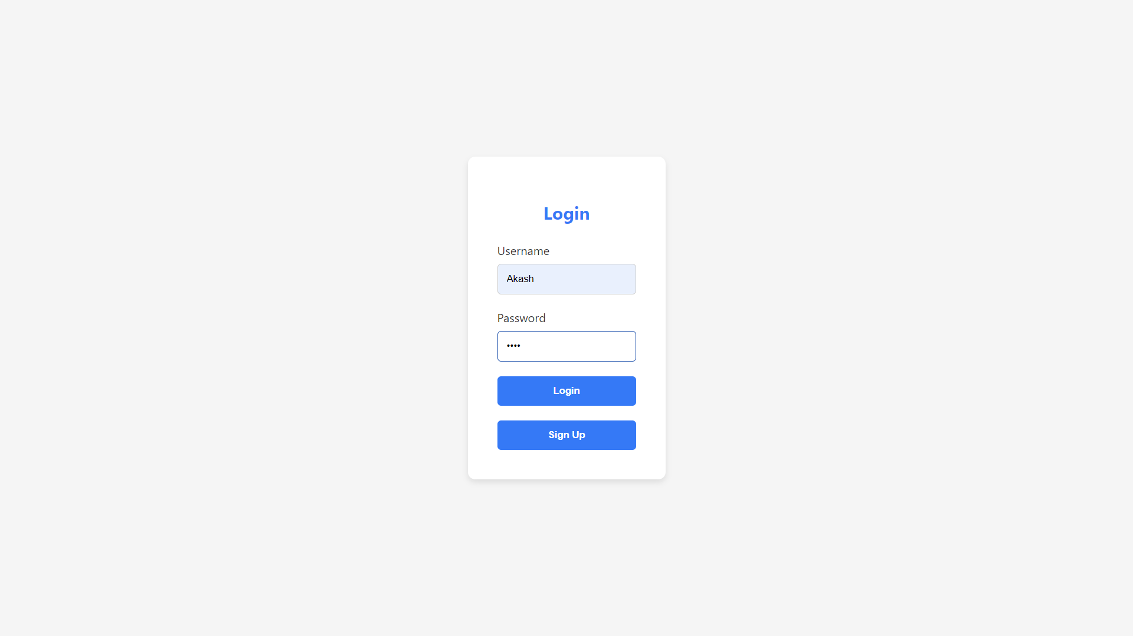

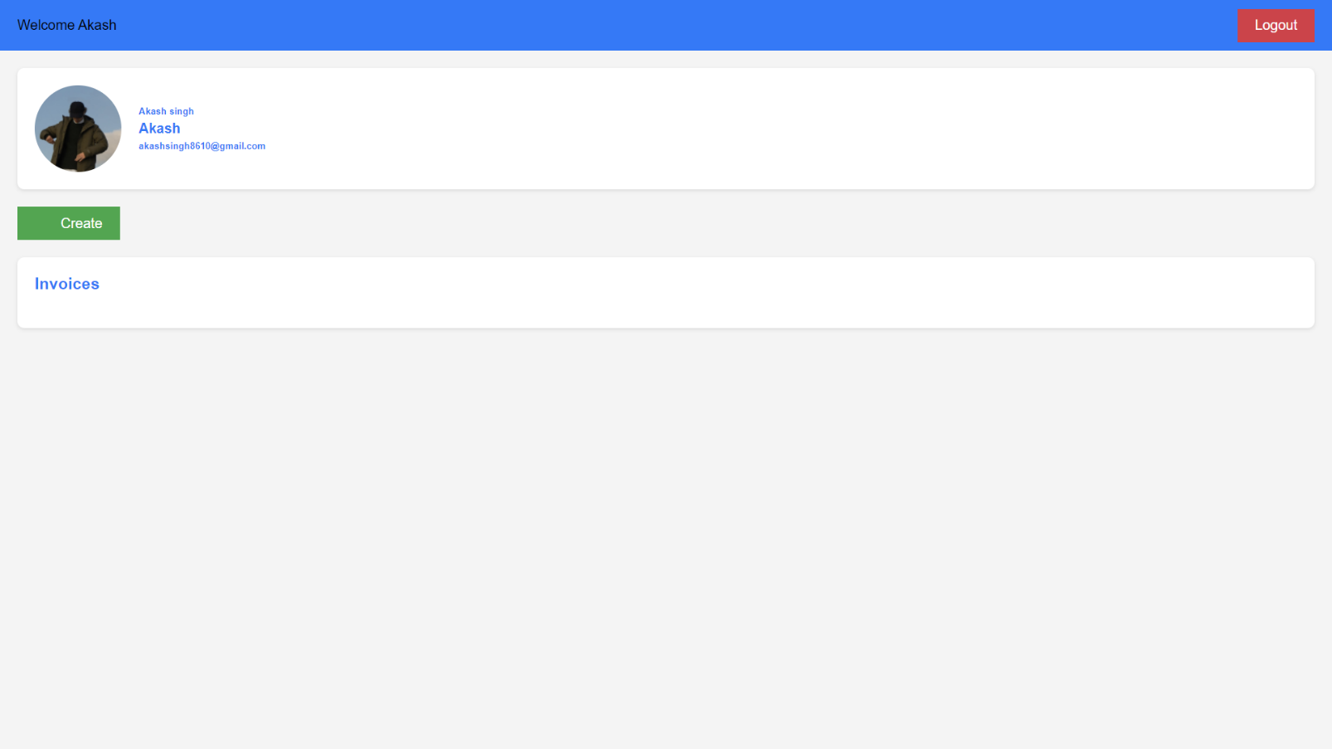

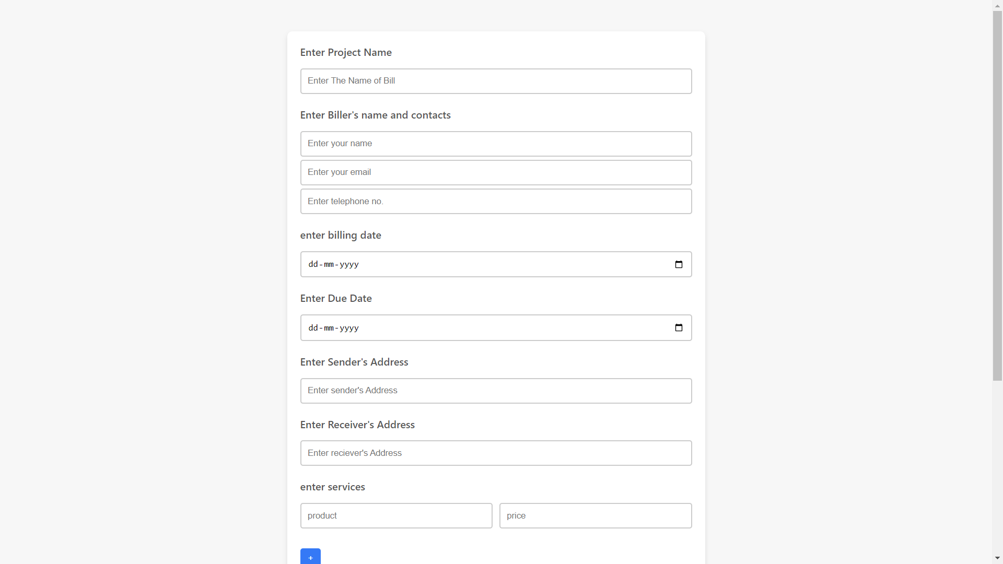

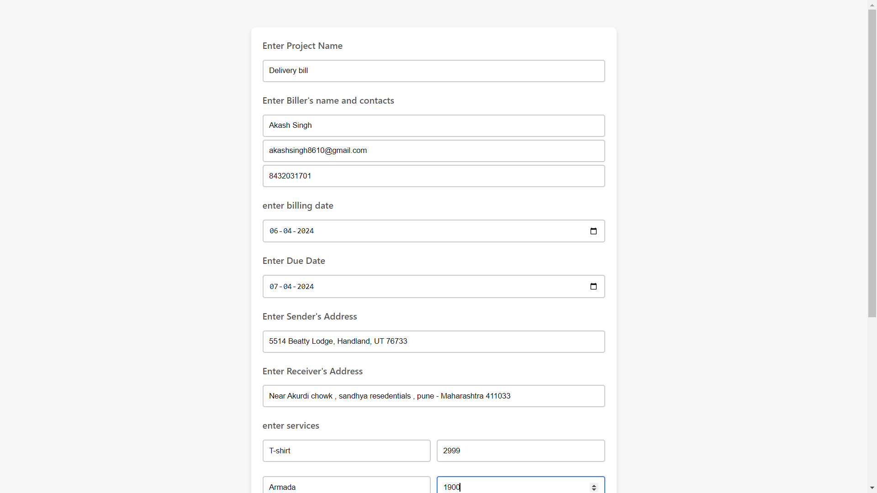

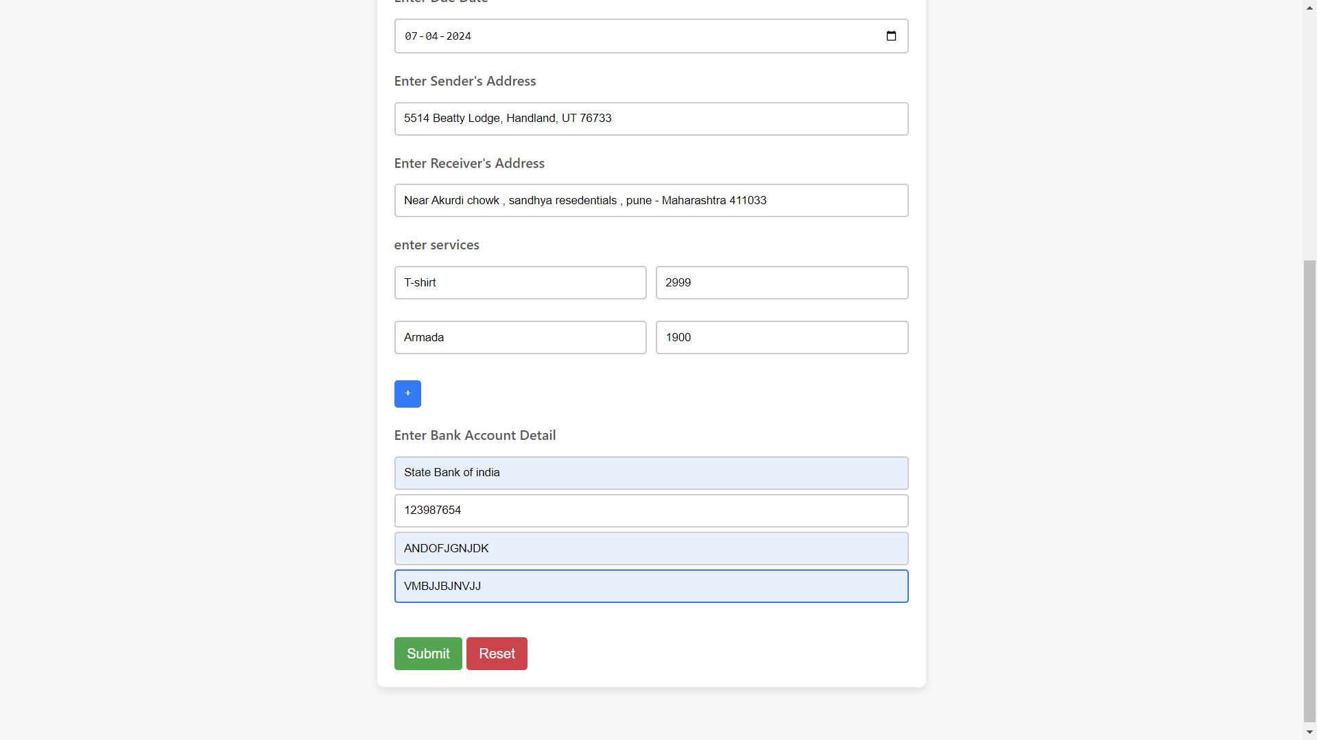

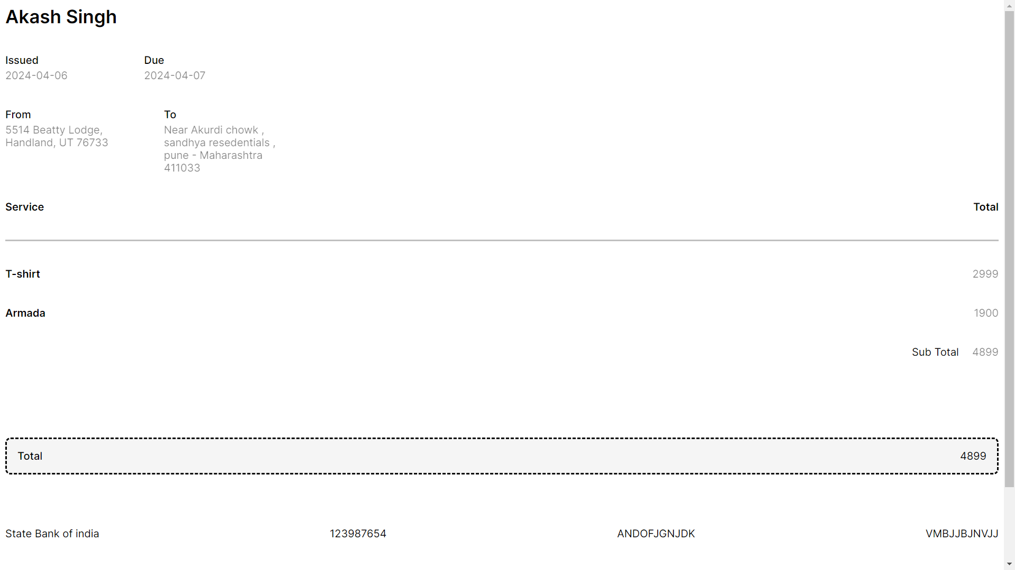

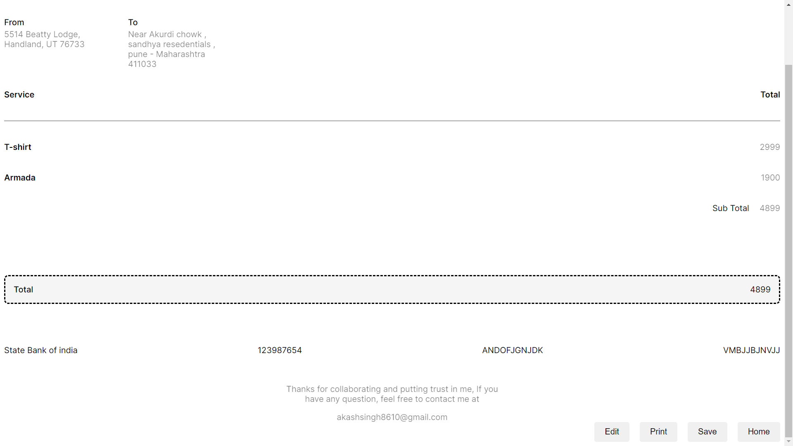

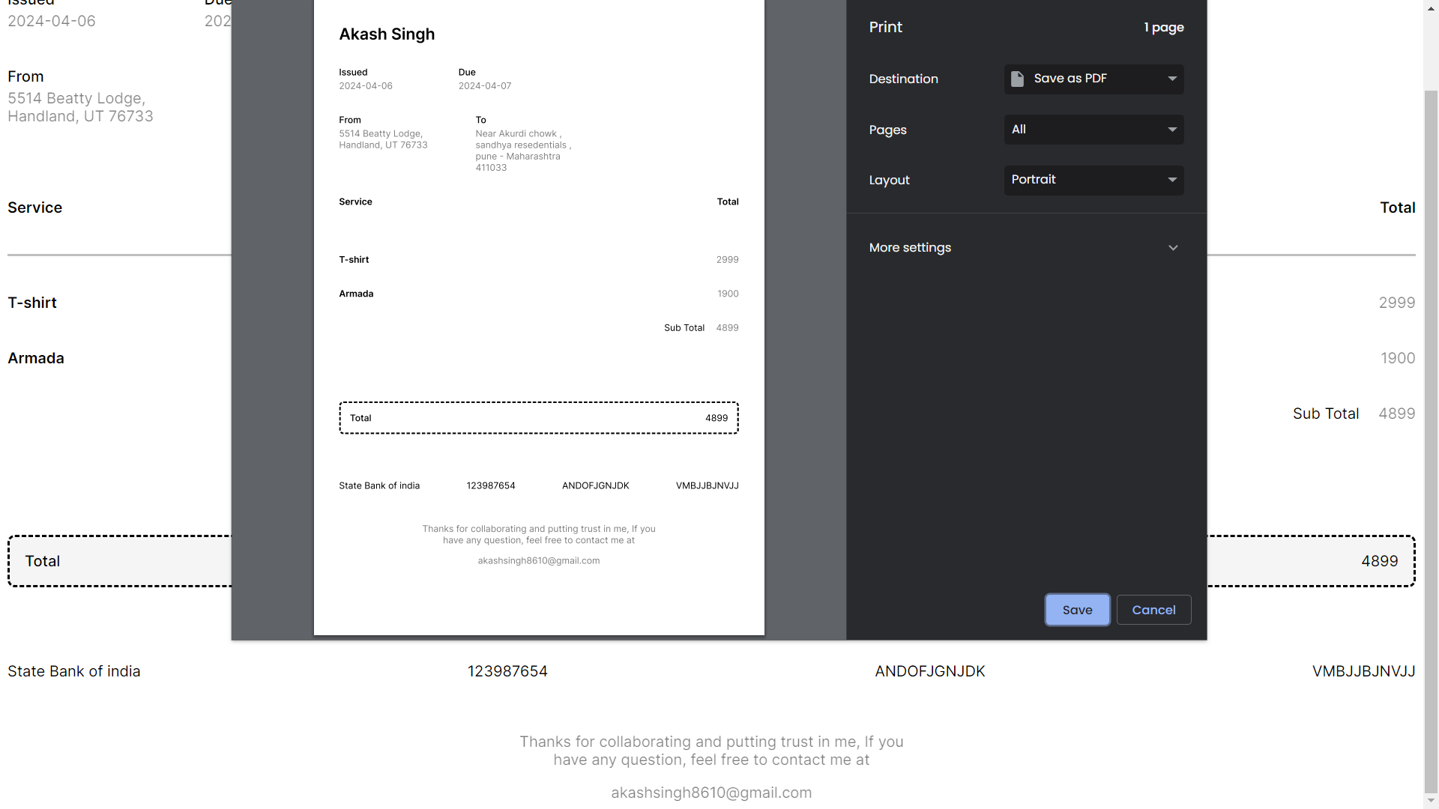

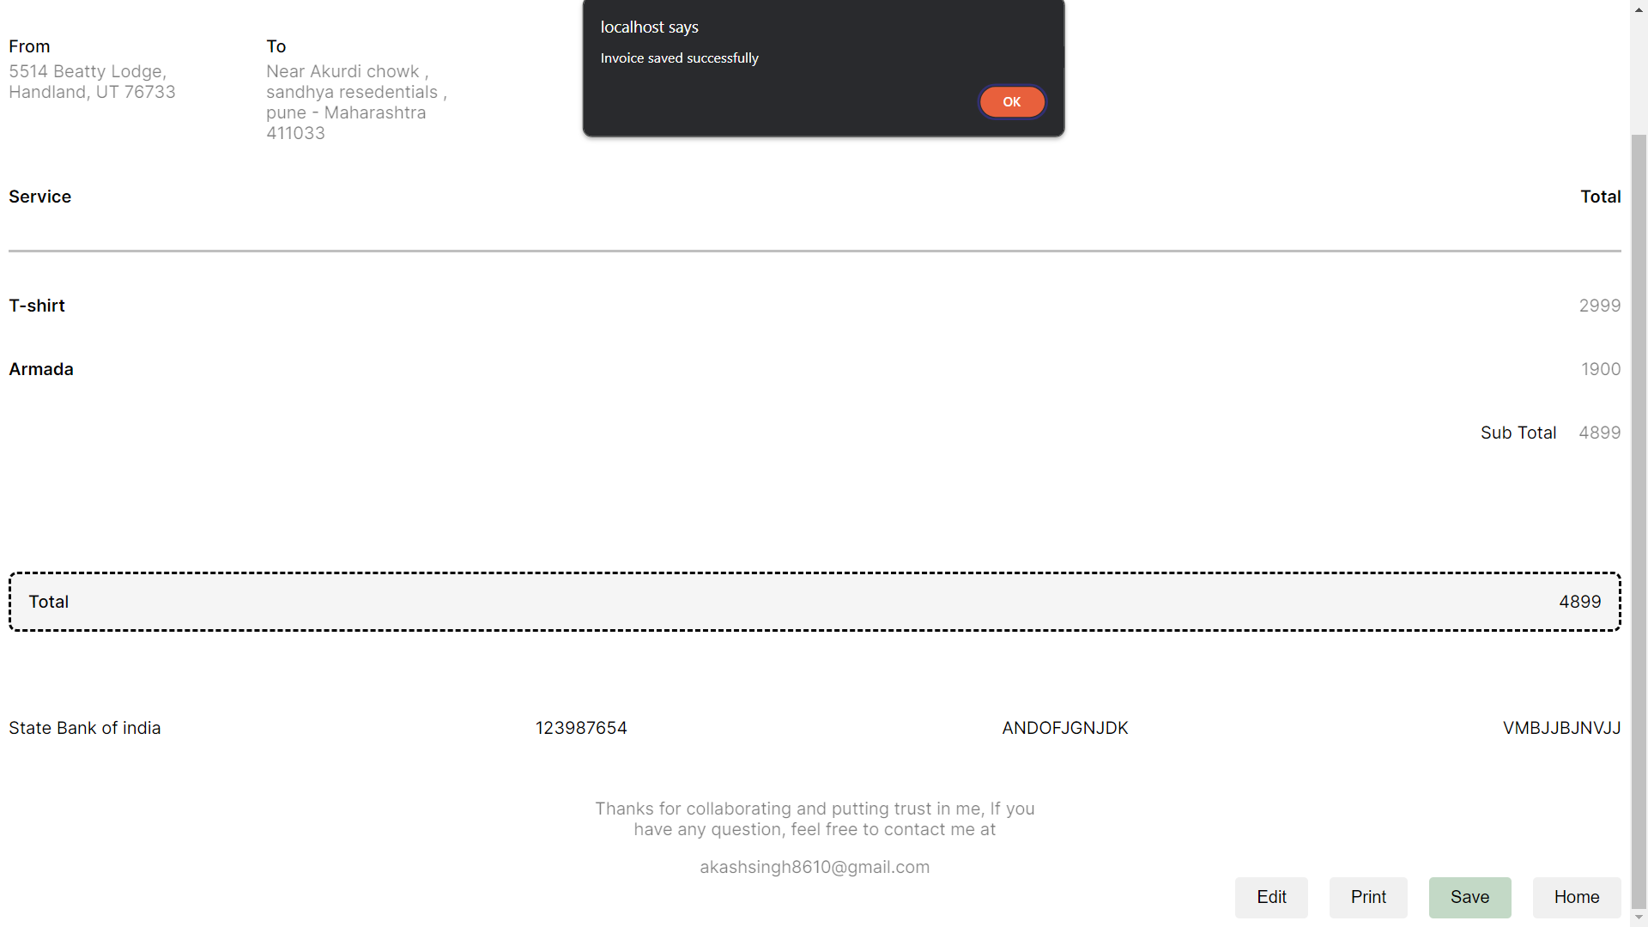

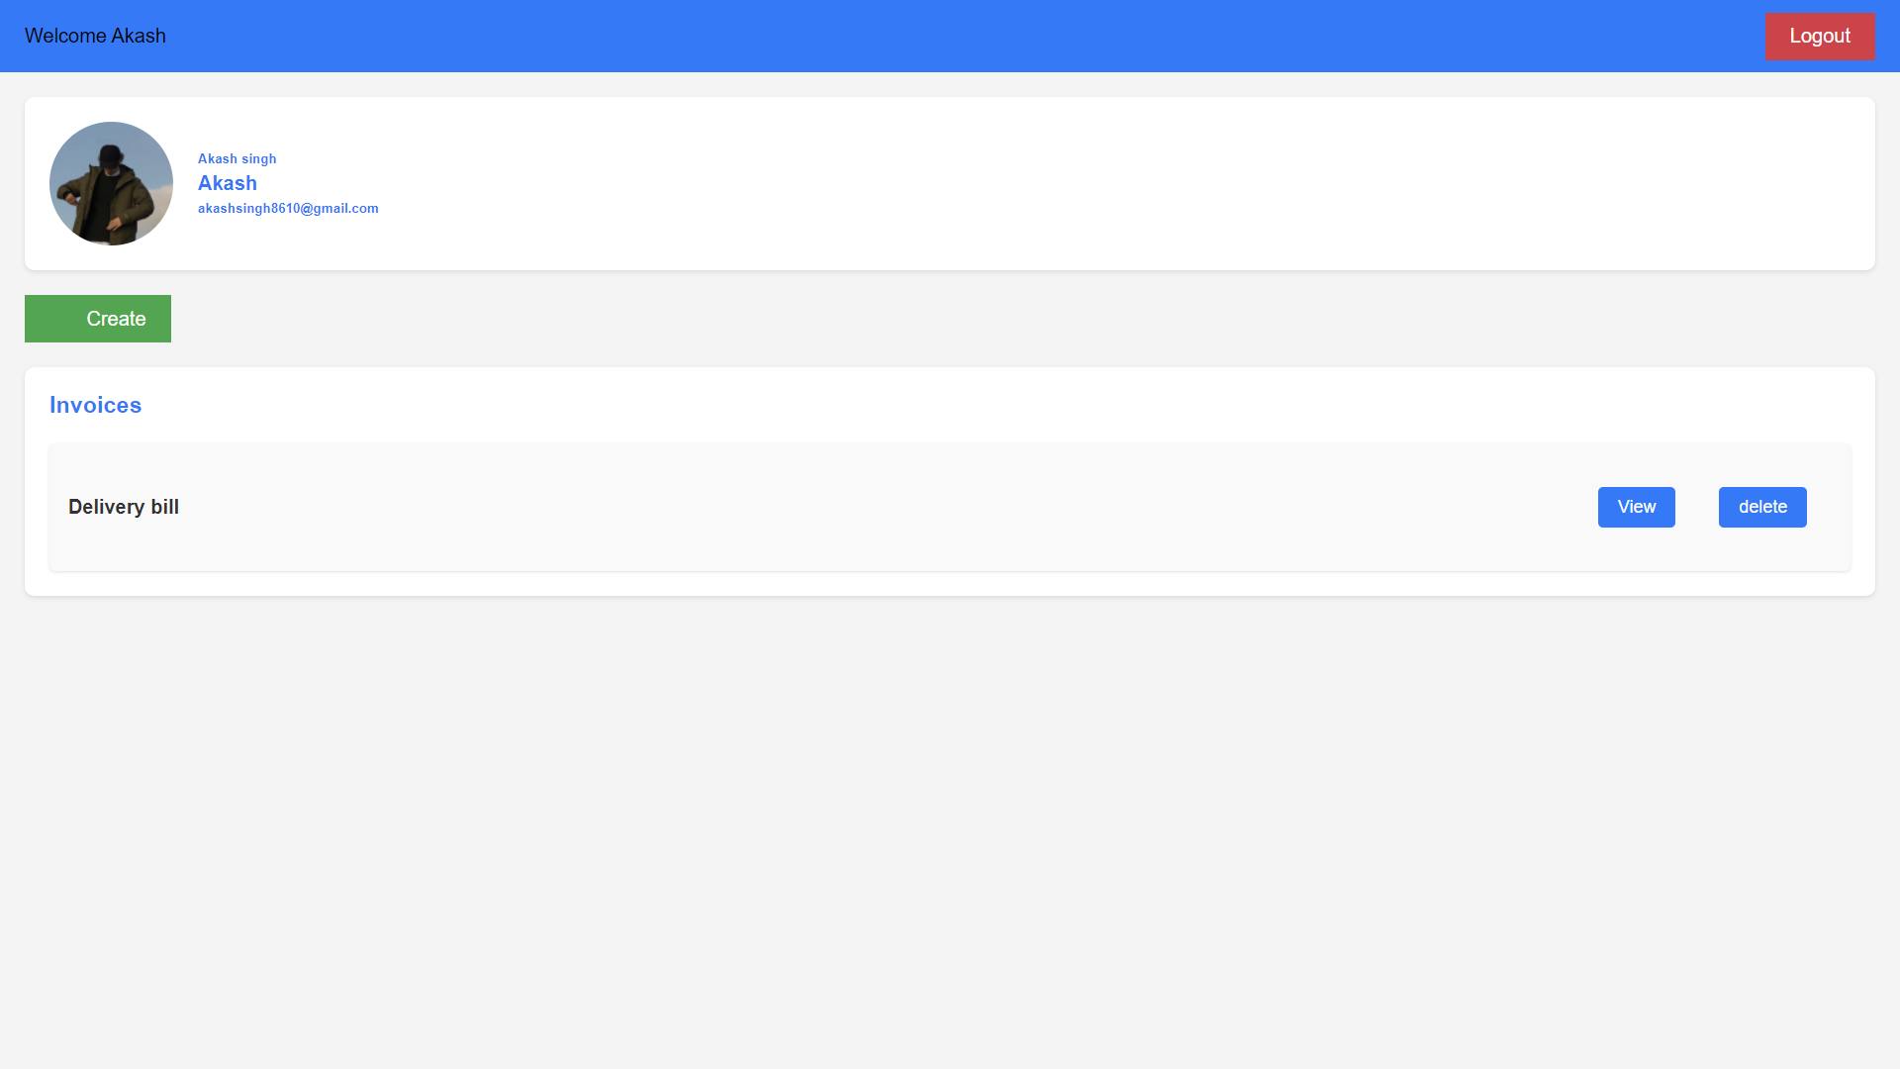

**TESTING STRATEGY:**

**User**

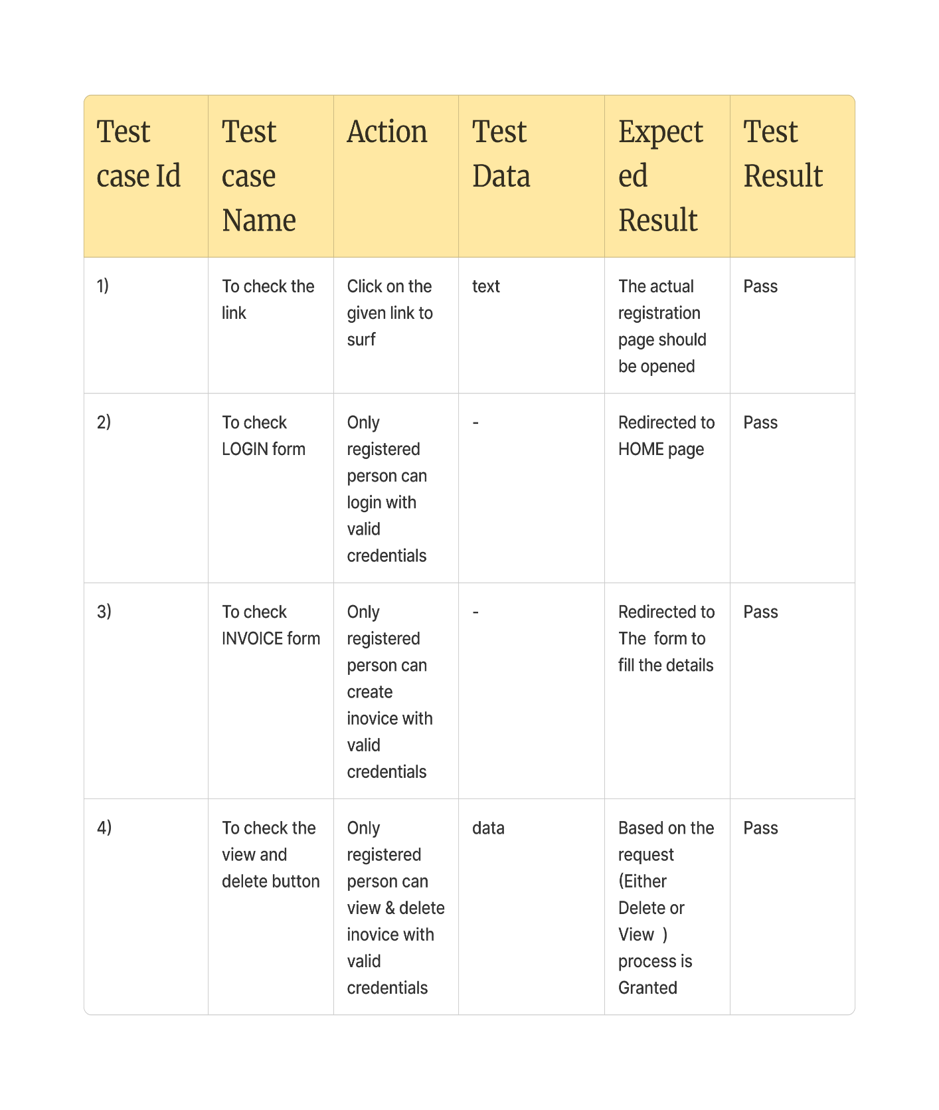

**LIMITATIONS :**

* Not very much templates for the invoice
* When a already created invoice is updated the information is added as new record in database
* User can’t add/alter their pictures
* Need improvement in UI
* Lacks of data security & leads to error prone results.

**FUTURE ENHANCEMENT:**

The current system is designed for users to create/update/alter/use invoices with very ease of

Comfort and easier manner, but currently in our application there’s only one template that can be increased for other types of users

* Adding More templates for other types of users as well
* Creating a standalone mobile application for Everyone, but mainly focusing on some group of people who doesn’t likes to use web for everything
* Customizable input form and invoices such that user can use and modify the templates.

**CONCLUSION:**

1.Our Motive was to create an application for the better and easy way to create invoices and

And store , view and delete them

**BIBLIOGROPHY:**

**https://www.youtube.com/watch?v=KB6Yg5hNrqc&pp=ygUVbGl2ZSBpbnB1dCB0aHJvdWdoIGpz**